LTSPICE Sımulatıon

The controller options are narrowed down to UC3842, LT1242, and LT3748. UC3842 and LT1242 are equivalent of each other. LT3748 has a simpler control loop and doesn’t require a third winding whereas UC3842/LT1242 require a third winding to fed the controller and they have much complex feedback loop. However, the secondary side regulation of UC3842/LT1242 results in a more robust an stable system. Moreover, LT3748 cant be found in Turkey stock. Thus, UC3842/LT1242 are chosen as controller.

Controller in the simulation is chosen as LT1242. Since UC3842 and LT1242 are equivalent of each other, the circuitry in Figure x. can be implemented with UC3842 too.

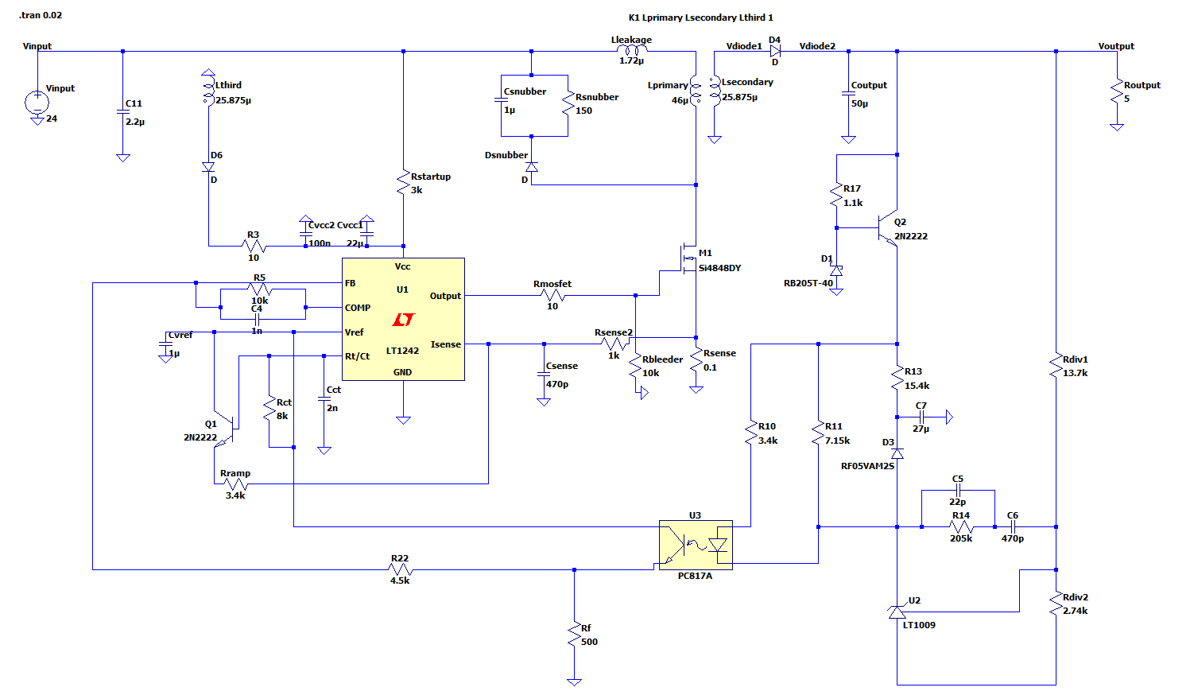

Figure x. The schematic of the circuit

The important characteristics of the circuit for 24V and 48V inputs are displayed below.

**24V**

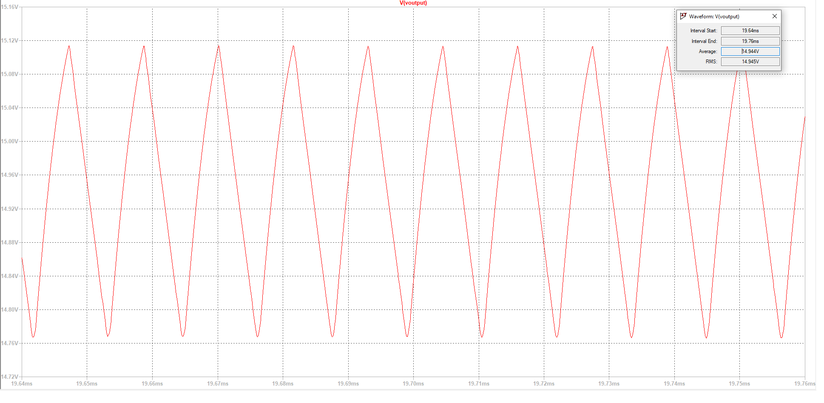

It is seen that the output voltage is approximately 14.95V and the voltage ripple is 0.34V.

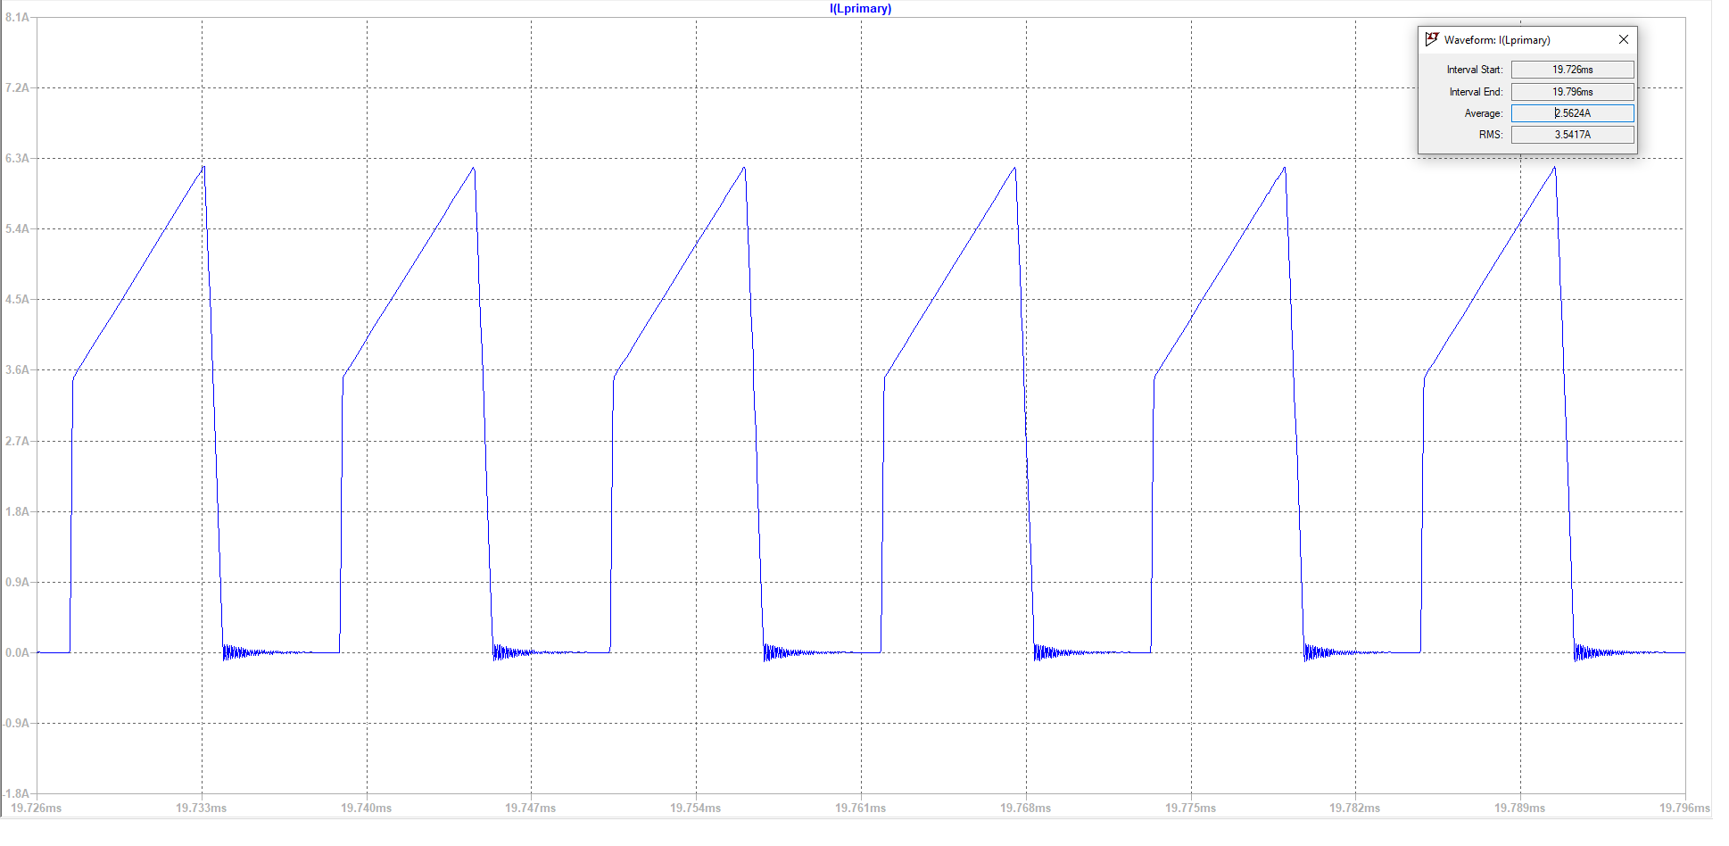

For primary cable, the minimum input voltage case is examined since it gives the maximum current. The RMS value of the primary current is 3.54A. Since the frequency is chosen as 70kHz, AWG25 cables are chosen to reduce skin effect. The cross-section of these cables are approximately 0.16mm2. Thus, 5 parallel cables are enough to make the average current density 4A/mm2.

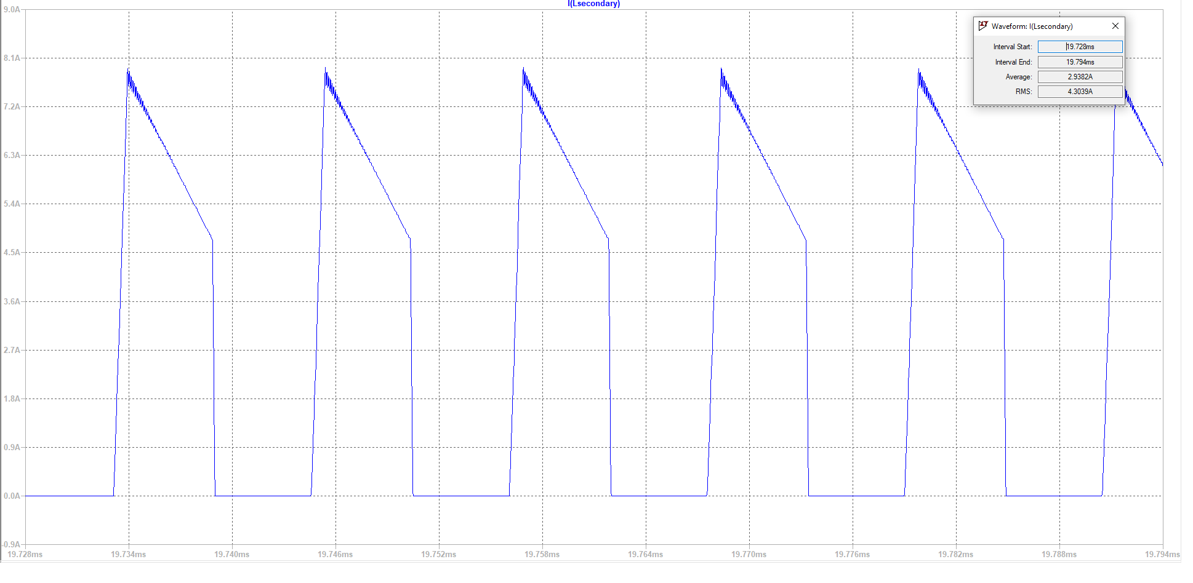

The RMS value of the secondary current is 4.31A. Thus, 7 parallel AWG cables are enough to make the average current density 4A/mm2.

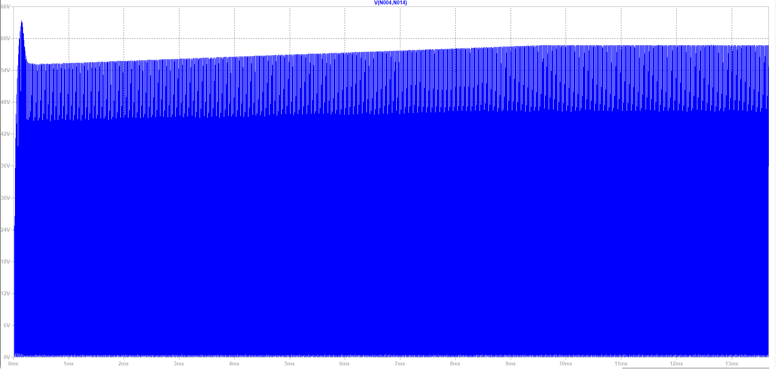

With the snubber design, it is seen that the mosfet voltage is reduced to 64V in transient state and 58V in steady state. Without the snubber, the mosfet voltage reaches 300V in transient state and 220V in steady state due to leakage inductance.

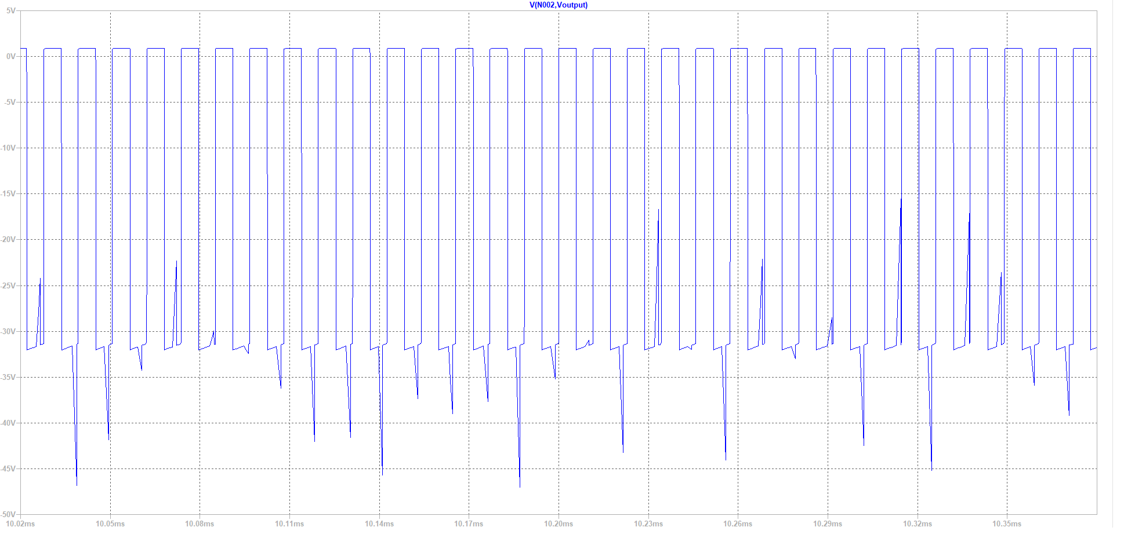

The maximum diode voltage is measured as 47V.

**48V**

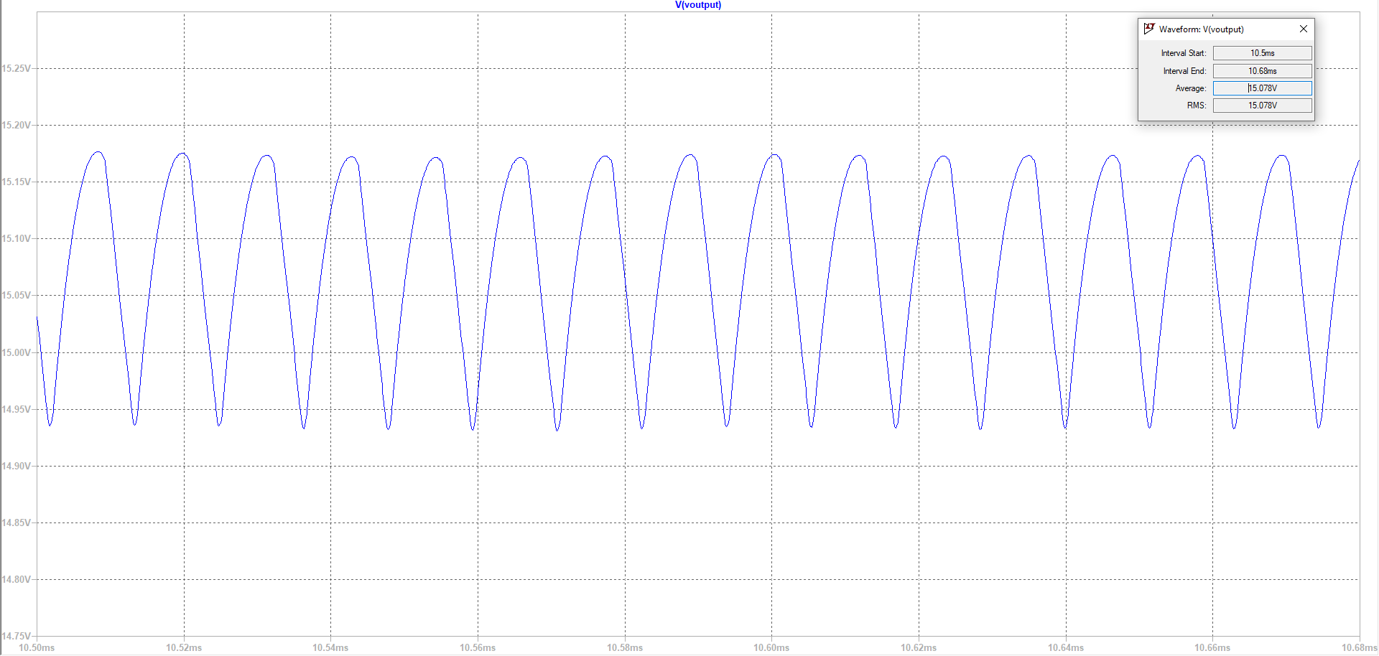

Output voltage is measured as 15.08V and the voltage ripple is 0.26V in steady state.

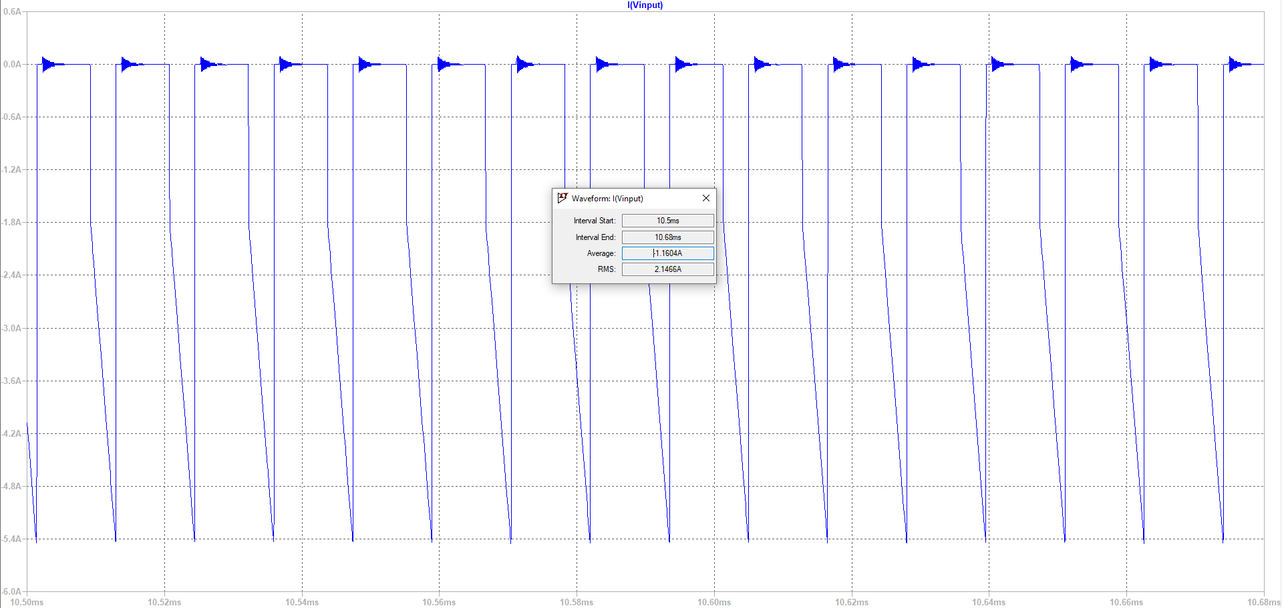

By calculating the average power from the average input current, the efficiency is approximately 81.5%.

For constructing the circuit, WeBench test environment of TI and the application notes of LT1242, UC3842 and UC2842 are used. The transformer parameters are revised after the test results. Detailed information about the subparts is explained below.

* **Snubber**

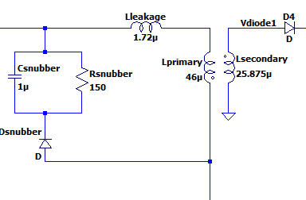

Figure x.: Snubber Circuit

The snubber circuit is used to remove the excess current from the leakage inductance when the switch is turned off.

* **Vcc**

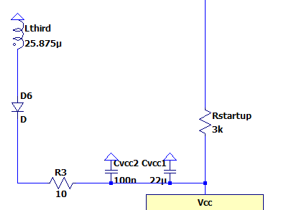

Figure x.: Power delivery to Vcc

A third winding is winded up to the transformer in order to feed the controller in the steady state operation. This winding has the same turn number as the secondary winding and it delivers power to the controller. The Rvcc1 and Rvcc2 are used for filtering deviations in the Vcc voltage. Rvcc2 is a small ceramic or film capacitor that is used for decreasing ESR value of the large capacitor.

Rstartup resistance is used in delivering power during start up, when the winding cannot generate enough voltage. It increases the source impedance. The value of Rstartup is chosen smaller than the regular applications (100kΩ in regular) since the input voltage is smaller than regular applications. (48V max in our design).

* **Vref**

Vref generates 5V constant output when Vcc is higher than the threshold voltage (12V for UC3842-LT1242). This pin is used in more than one subpart as voltage reference. To reduce the effect on voltage deviations in Vcc on the Vref voltage, a large capacitor (1uF) is used as filter.

* **Isense**

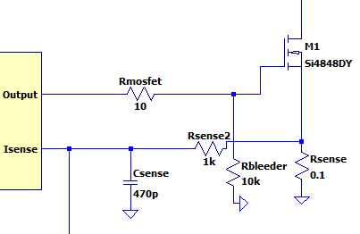

Figure x.

Isense pin measures the input current via the voltage drop on the Rsense resistor. Rsense is chosen as 0.1 Ω to set current 10A by the equation below.



The Rbleeder is placed to prevent the unwanted mosfet turn-on due to leakage currents. Rsense2 and Csense construct a small RC filter and it is used to suppress switch transients.

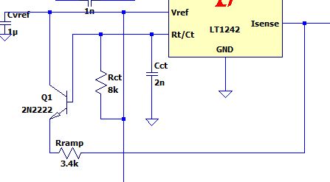

Figure x. Oscilator ramp generator

A ramp signal is generated by using the Q1 transistor and the Cct (frequency set capacitor) in order to compensate the slope of the Rsense voltage. A fraction of this ramp signal is summed up with the feedback voltage via Rramp resistor.

* **Rc/Rt**

The Rrt (frequenc set resistor) and Cct (frequency capacitor) is roughly set via the equation below. The capacitor value should be higher than 1nF and the resistance should be higher than 5kΩ according to the datasheet. After tuning the circuit in simulation, these values are chosen as Rct = 8k and Cct = 2nF.

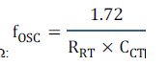

* **Compensation Loop**

The main aim of the compensation loop is to tune closed loop poles, zeros, gain and phase response in order to obtain a stable feedback loop. There are three main parts which are error amplifier of the controller, voltage regulator (TL431) and optocoupler.

-Voltage Regulator

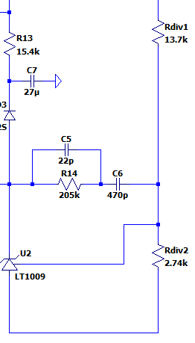

Figure x.

The voltage regulator on the secondary side is used the node voltage to approximately 2.5V. The TL431 is used as regulator due to its accuracy and internal opamp. Rdiv1 and Rdiv2 are selected according to the desired power consumption. Rdiv1 (Rfbu) is chosen as in the equation below where RefTL431 is 2.5V and Ifb is chosen as 0.9mA.

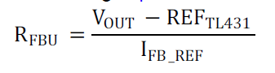

Rdiv1 iis chosen as 13.7kΩ. Then, Rdiv 2 is chosen as 2.74kΩ by the following equation.

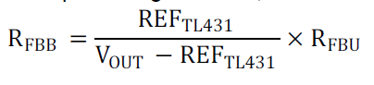

R14, C5 and C6 are chosen in order to place a compensator zero for improving the phase margin at bandwidth frequency.

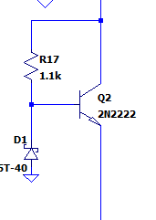

Figure x.

The circuitry indicated in Figure x is responsible for providing sufficient cathode current to the TL431.

-Optocoupler

The optocoupler has a parasitic pole which is hard to characterize over frequency. So, by adding the Rf, we move this pole further away from the range of interest.

-Error Amplifier

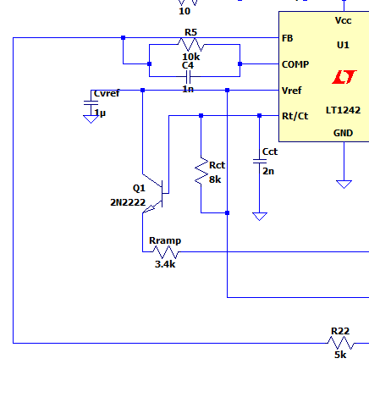

Figure x.

The Vcomp pin is the output of the error amplifier. The R5 and C4 that are connected to this pin is responsible for adding a compensation pole. R22 is added to the loop in order to increase the DC gain. This helps improving the bandwidth.